Expletive Subject

✅ What is Expletive Subject
# Source: AI Source: Provided by: [Data Path: Persons Table -> ID Column: 1, Name_En Column: Motasem Essam] -> From: [Chatgpt (GPT-4-turbo)] on [8/4/2025]
An expletive subject is a placeholder word—typically “there” or “it”—that occupies the subject position in a sentence, while the real subject comes later.
These are sometimes called dummy subjects or syntactic subjects because they have no semantic (meaningful) content.

🔹 Common Expletive Words:
# Source: AI Source: Provided by: [Data Path: Persons Table -> ID Column: 1, Name_En Column: Motasem Essam] -> From: [Chatgpt (GPT-4-turbo)] on [8/4/2025]
- There – used to introduce the existence or presence of something
- It – used to refer to time, weather, distance, or to introduce clauses/phrases

🔹 Structure Patterns:
# Source: AI Source: Provided by: [Data Path: Persons Table -> ID Column: 1, Name_En Column: Motasem Essam] -> From: [Chatgpt (GPT-4-turbo)] on [8/4/2025]
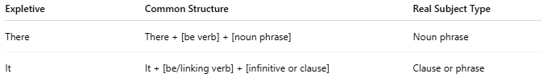
Expletive | Common Structure | Real Subject Type
There | There + [be verb] + [noun phrase] | Noun phrase
It | It + [be/linking verb] + [infinitive or clause] | Clause or phrase

🔹 Examples with "There":
# Source: AI Source: Provided by: [Data Path: Persons Table -> ID Column: 1, Name_En Column: Motasem Essam] -> From: [Chatgpt (GPT-4-turbo)] on [8/4/2025]
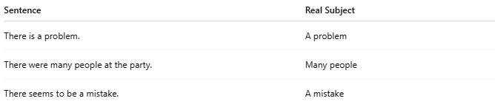
Sentence | Real Subject
There is a problem. | A problem
There were many people at the party. | Many people
There seems to be a mistake. | A mistake

🔹 Examples with "It":
# Source: AI Source: Provided by: [Data Path: Persons Table -> ID Column: 1, Name_En Column: Motasem Essam] -> From: [Chatgpt (GPT-4-turbo)] on [8/4/2025]
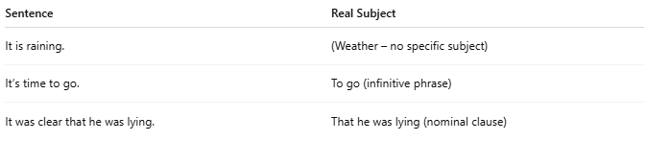
Sentence | Real Subject
It is raining. | (Weather – no specific subject)
It’s time to go. | To go (infinitive phrase)
It was clear that he was lying. | That he was lying (nominal clause)

🔍 Tips:
# Source: AI Source: Provided by: [Data Path: Persons Table -> ID Column: 1, Name_En Column: Motasem Essam] -> From: [Chatgpt (GPT-4-turbo)] on [8/4/2025]
- “There” is used when talking about existence or presence.
- “It” is used to delay the real subject, describe conditions, or introduce clauses.
- The real subject usually comes after the verb.

